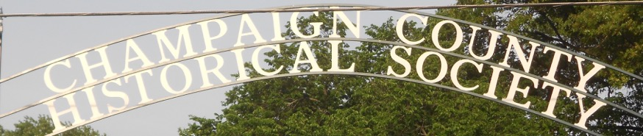
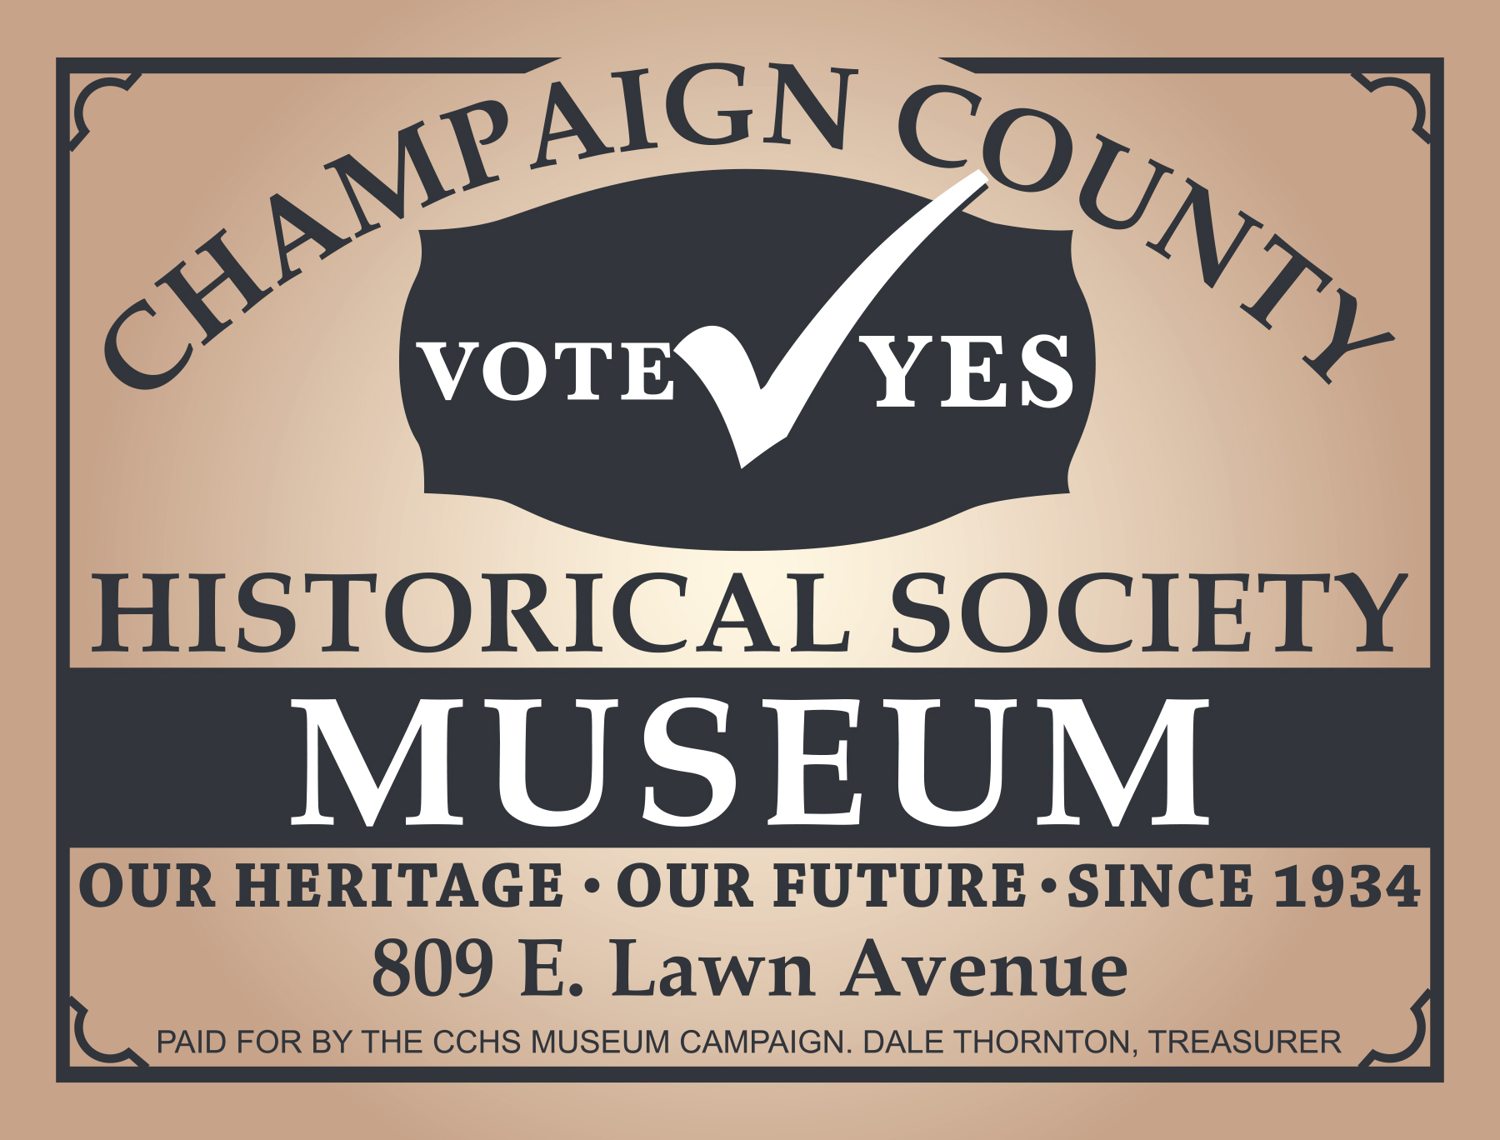
Est. 1934 November/December 2018
CHAMPAIGN CHRONICLES
809 E Lawn Ave Urbana, Ohio 43078 www.champaigncountyhistoricalmuseum.org
This is it! We have momentum and are moving forward. How can each of you help put us over the top?

ASK 5 REGISTERED VOTERS TO SUPPORT US!
CLEANING UP
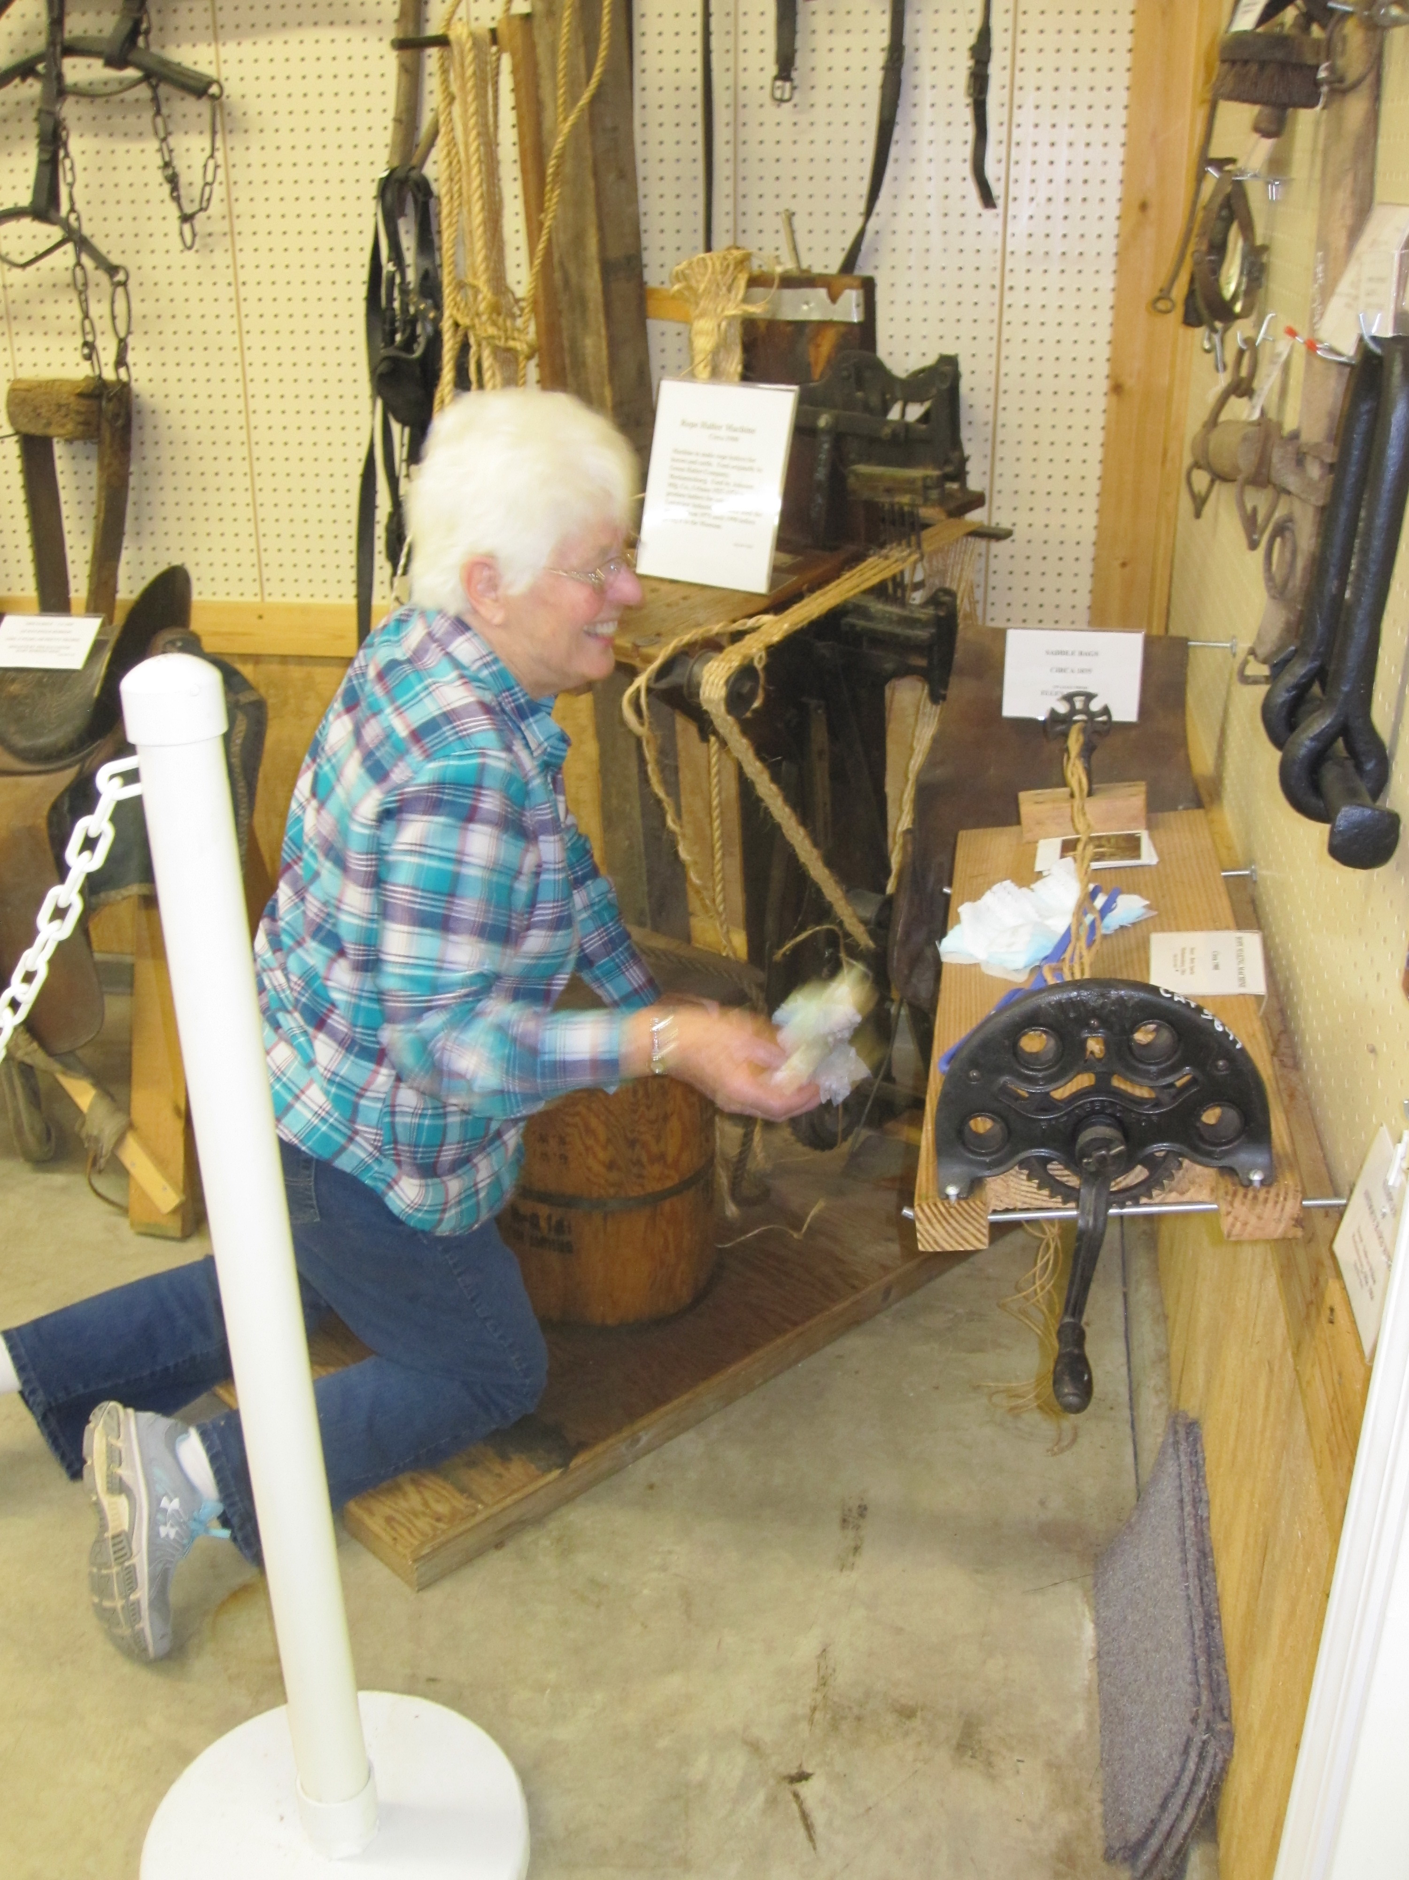
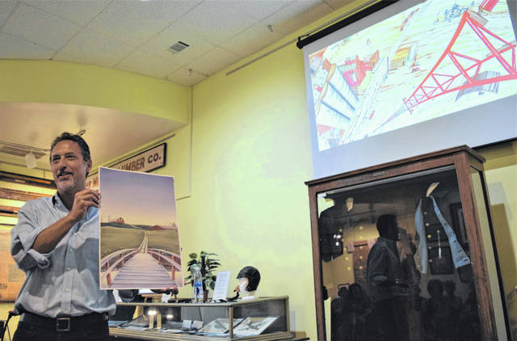
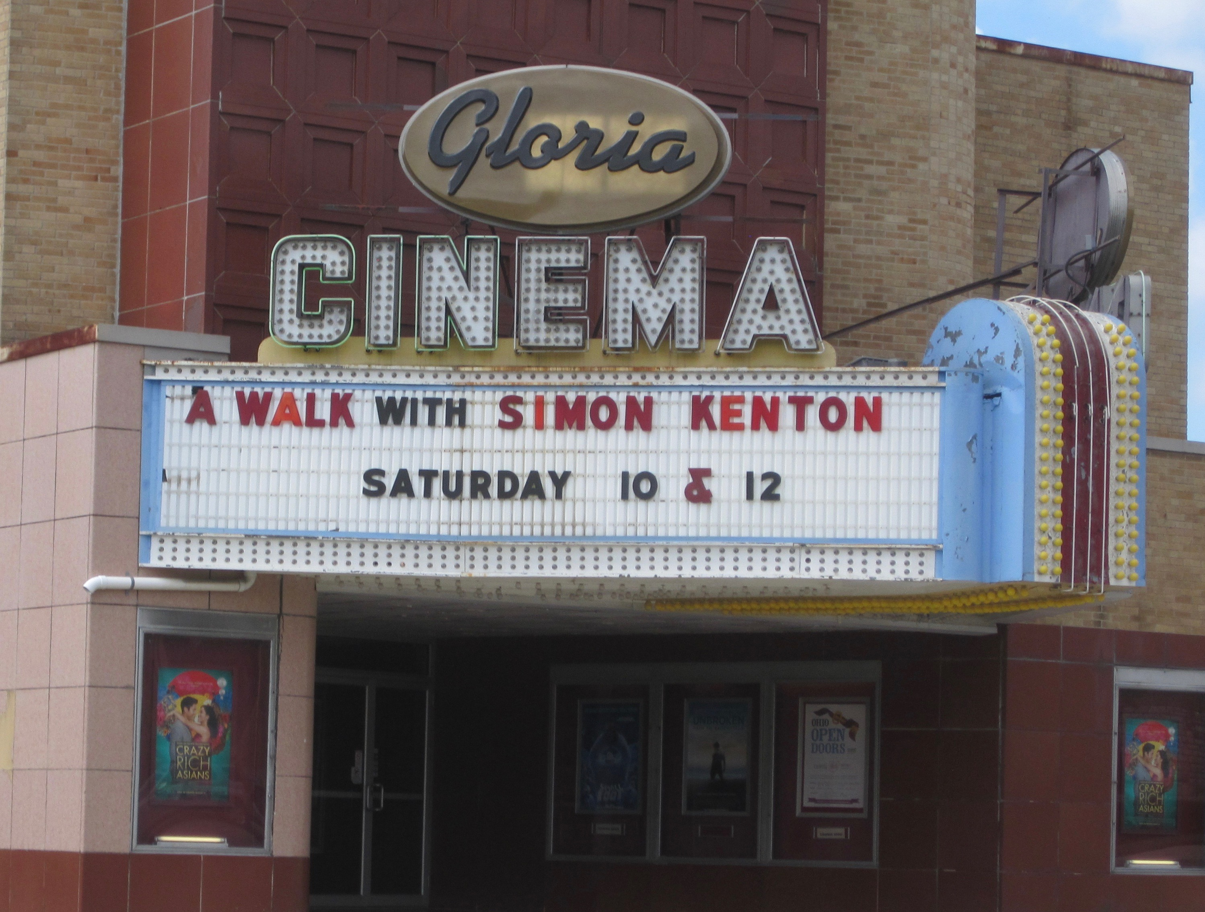
We are all-volunteer at this date, and our volunteers stepped up in a big way to clean and shine the museum prior to our very successful Ohio Open Doors event on Sept. 15. Of the 260 historic sites available state wide, 12 were hosted by CCHS in Champaign County. We estimate that about 300 people attended our sites that day. Special events included two showings of “A Walk With Simon Kenton” at the historic Gloria Theatre and a wonderful multi-media performance by Scott Kirby in the museum.
Nancy Donohoe works in “The Barn”
PRESIDENT’S UPDATE

Based upon feedback received from last year’s election, we have made a major effort to increase our presence throughout the county and people have noticed! In the past year we have hosted a Perennial Theatre production, totally redesigned our web site, increased our facebook presence and programs, increased our membership from just over 200 to nearly 300, posted a page on LAC-TV (Channel 5), manned a booth at the county fair, hosted Ohio Open Doors, and opened the museum on Sunday afternoons. Perhaps most significantly, we have advanced our educational outreach program up several notches.

A number of supporters weighed in on last year’s campaign and suggested that many voters do not realize just how small the millage is. Here are the simple facts:
3/10 of a mil
$10 per year
on a property appraised at $100,000.
We are SO appreciative of those who have contributed to this campaign. -Dan Walter
HOOPLA PARADE
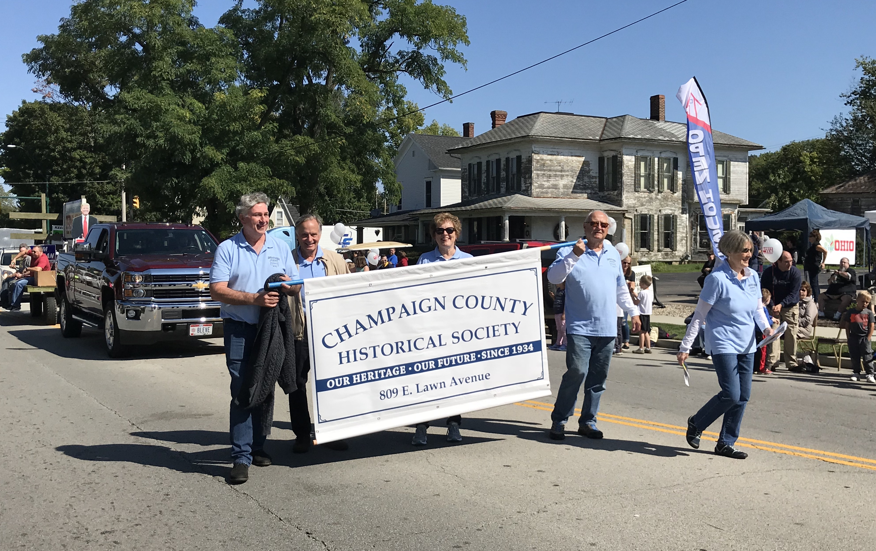
(September 22)

On Friday Oct. 5, CCHS hosted a special program presented by Chris Willis, Head of the Research Library at NFL Films since 1996. Willis, an Urbana U. graduate, has published six books with an emphasis on early pro football and has won an Emmy. He was inducted into the U.U. Athletic Hall of Fame the following day.
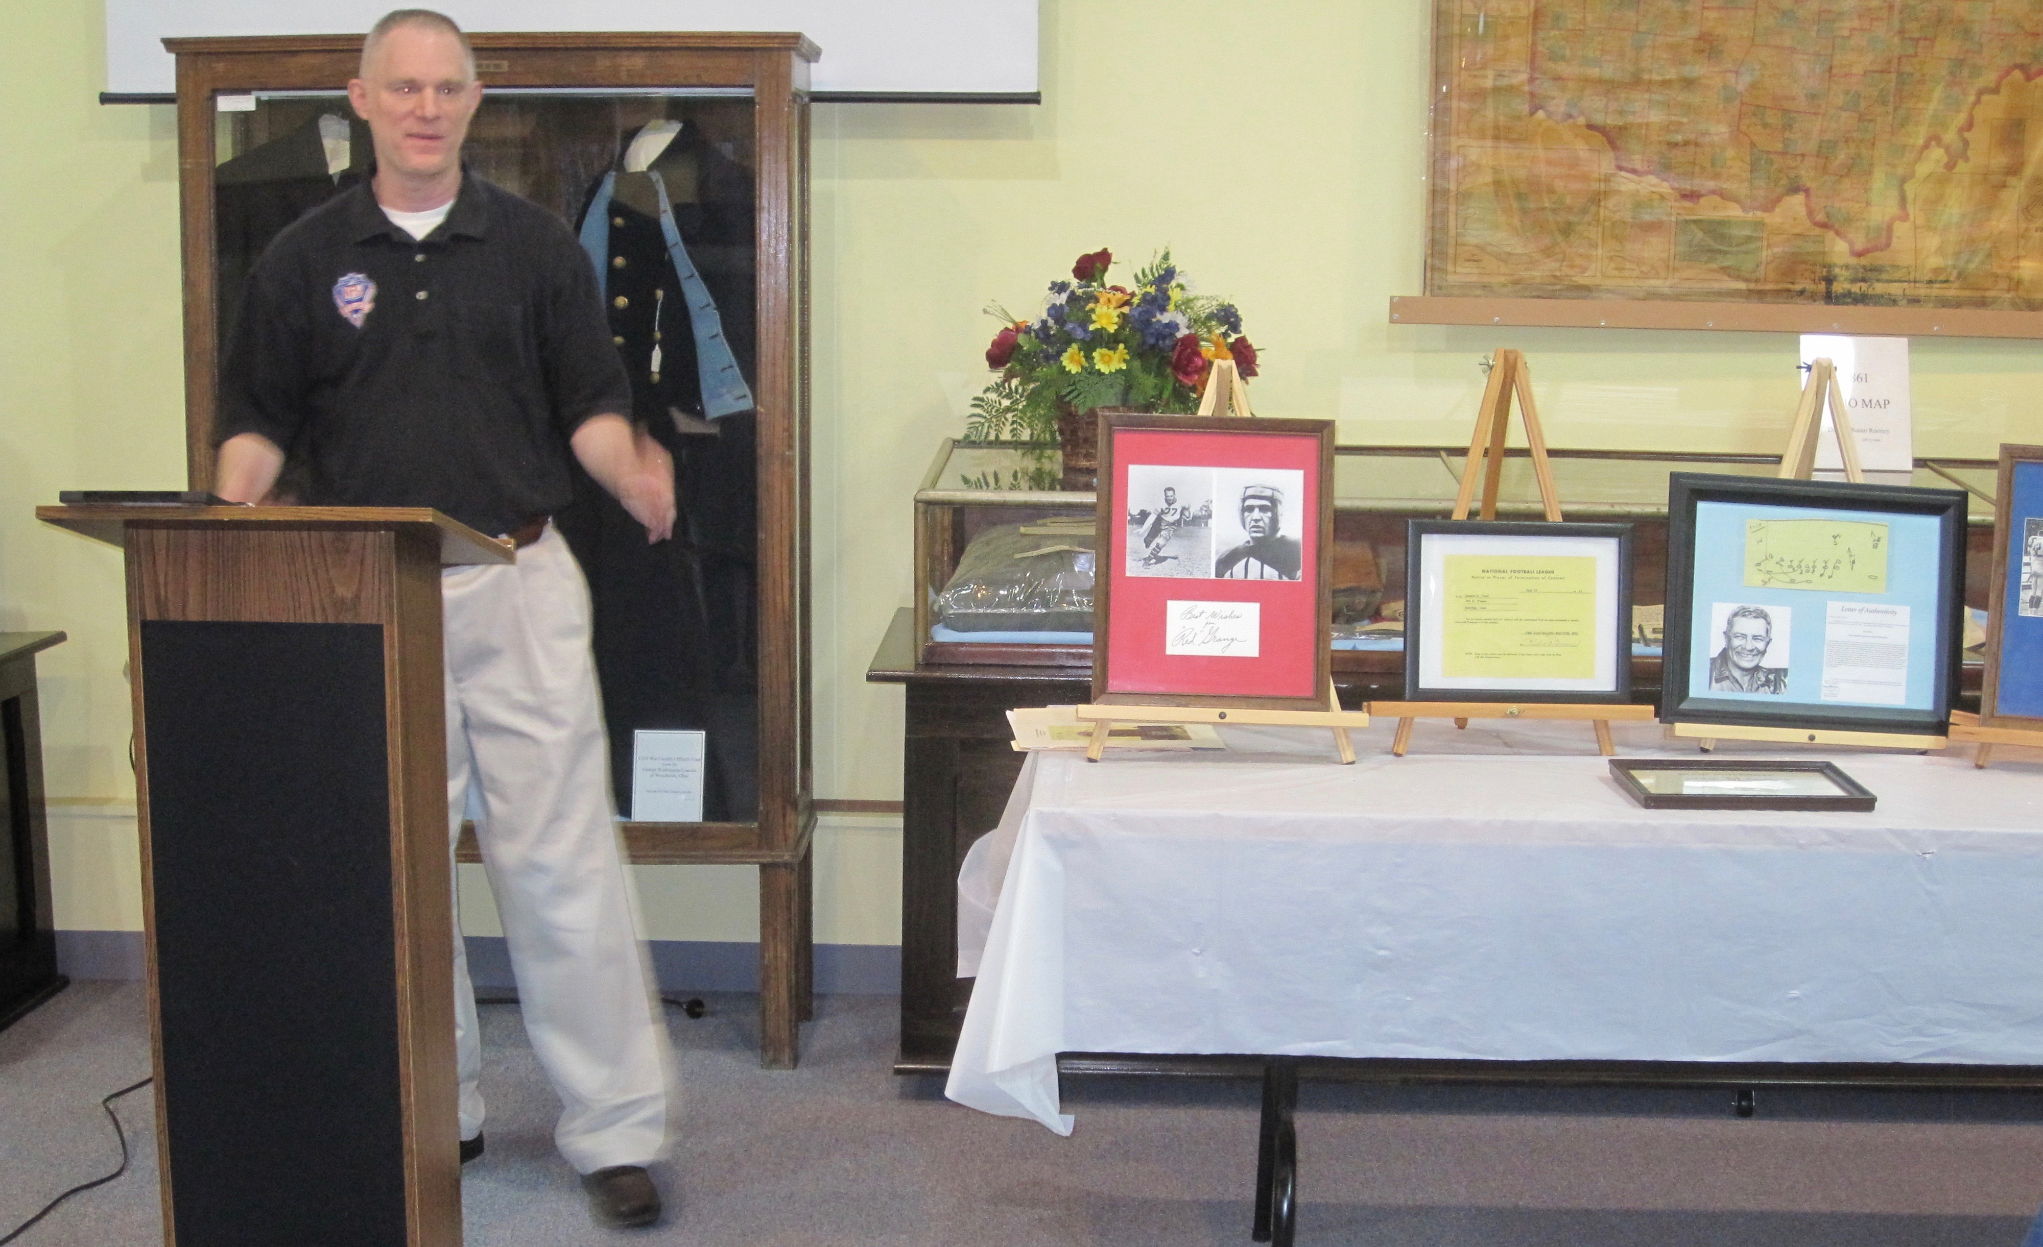
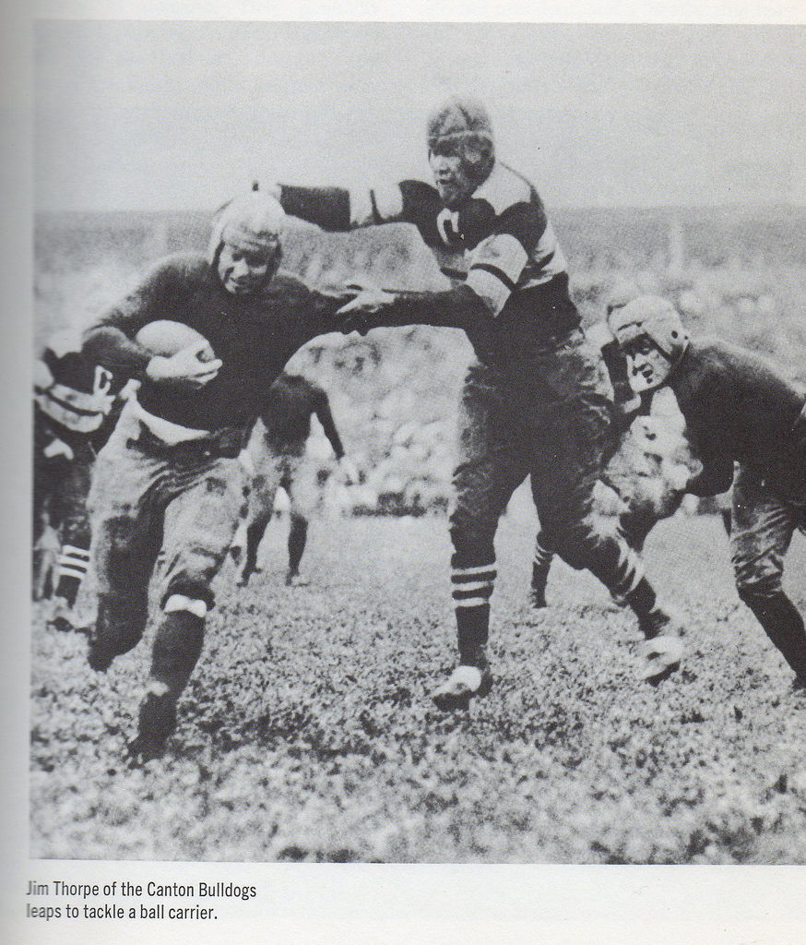
OKTOBERFEST

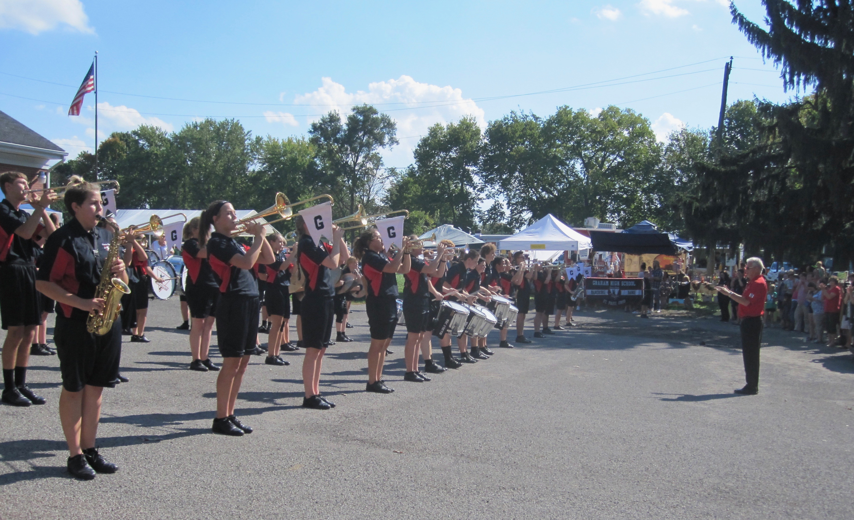
This year’s “new and improved” Oktoberfest event was also bigger and better. In addition to nearly 80 craft vendors, we hosted 4 food trucks, and an expanded entertainment series capped off by the famous “Dancing Band From Falcon Land.”
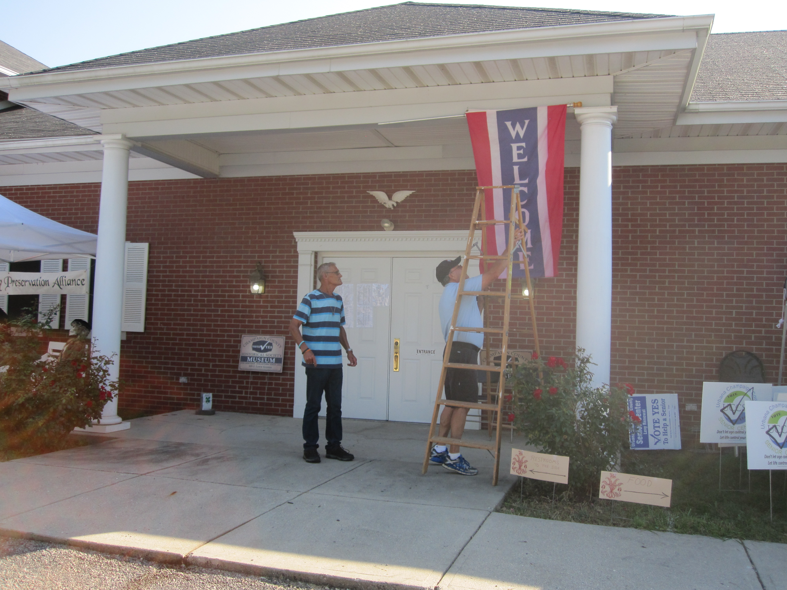
Moreover, the 46th edition of Oktoberfest, chaired by Dick Virts and Larry Headlee, was, as always, totally designed, set up (most of the day Friday), and operated by our dedicated corps of volunteers including B.S.A. Troop 258.

COMING EVENTS

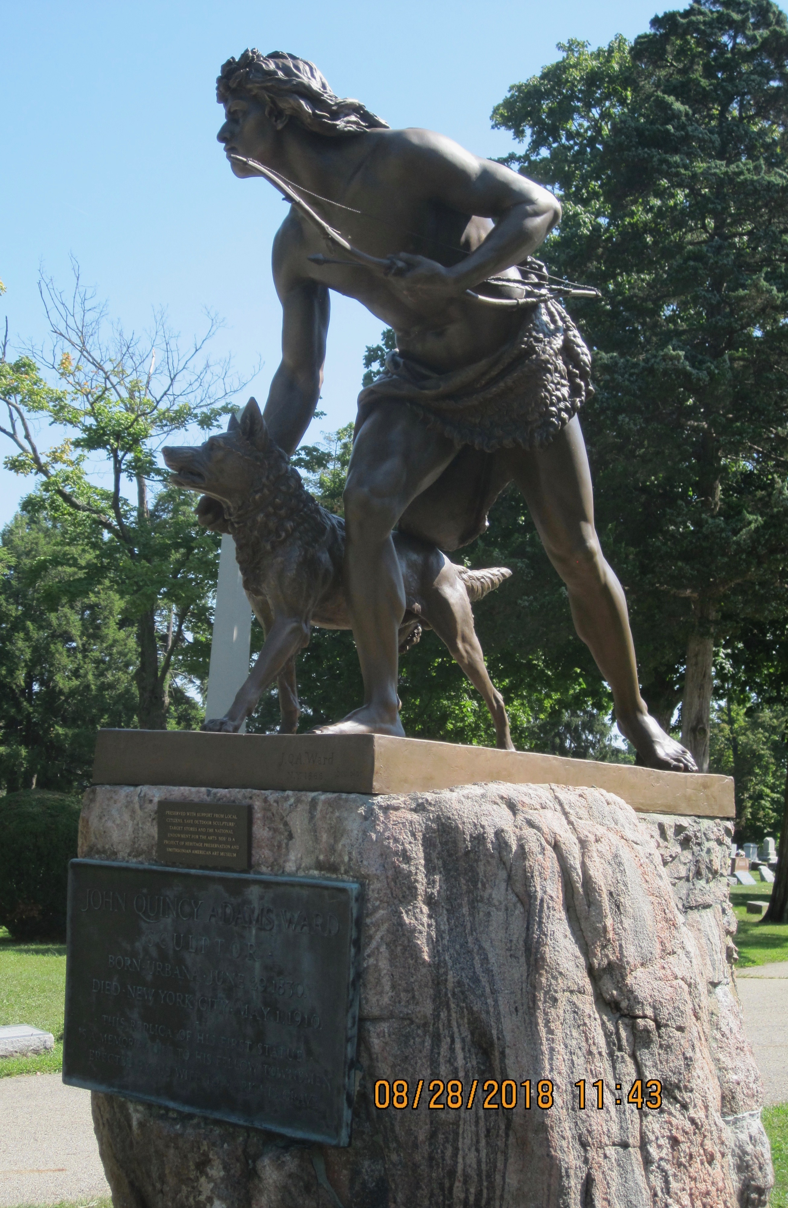
“The Indian Hunter”

At 10:00 AM on Saturday Oct. 27 J.Q.A. Ward’s sculpture, “The Indian Hunter,” will be rededicated at Oak Dale Cemetery, Urbana, and the public is invited. Earlier this year CCHS members Marty and Lynn Reich noticed that the sculpture was showing signs of deterioration. They then coordinated a campaign which resulted in the complete restoration of Ward’s piece by local artist Mike Major.

John Quincy Adams Ward, grandson of Col. William Ward, was America’s premier sculptor in the Nineteenth Century; there are six of his pieces in New York’s Central Park alone including the original of our “Indian Hunter,” and Ward’s “Washington” famously overlooks Wall Street. CCHS is a co-sponsor of the restoration and will provide historical background at the event.

Civil War, Agriculture, and Politics: Three Stories.

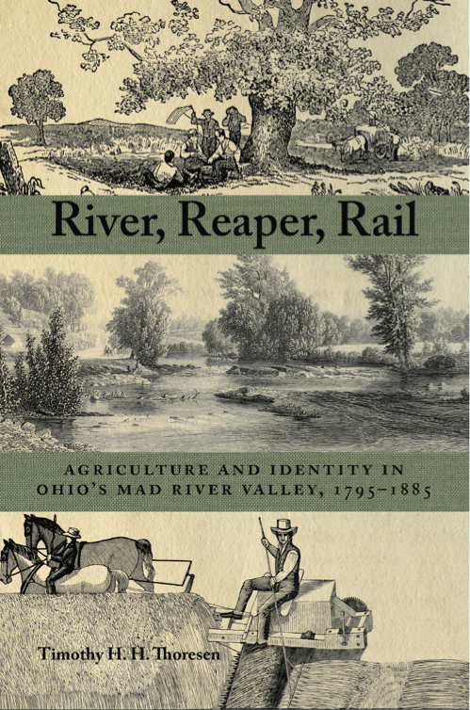
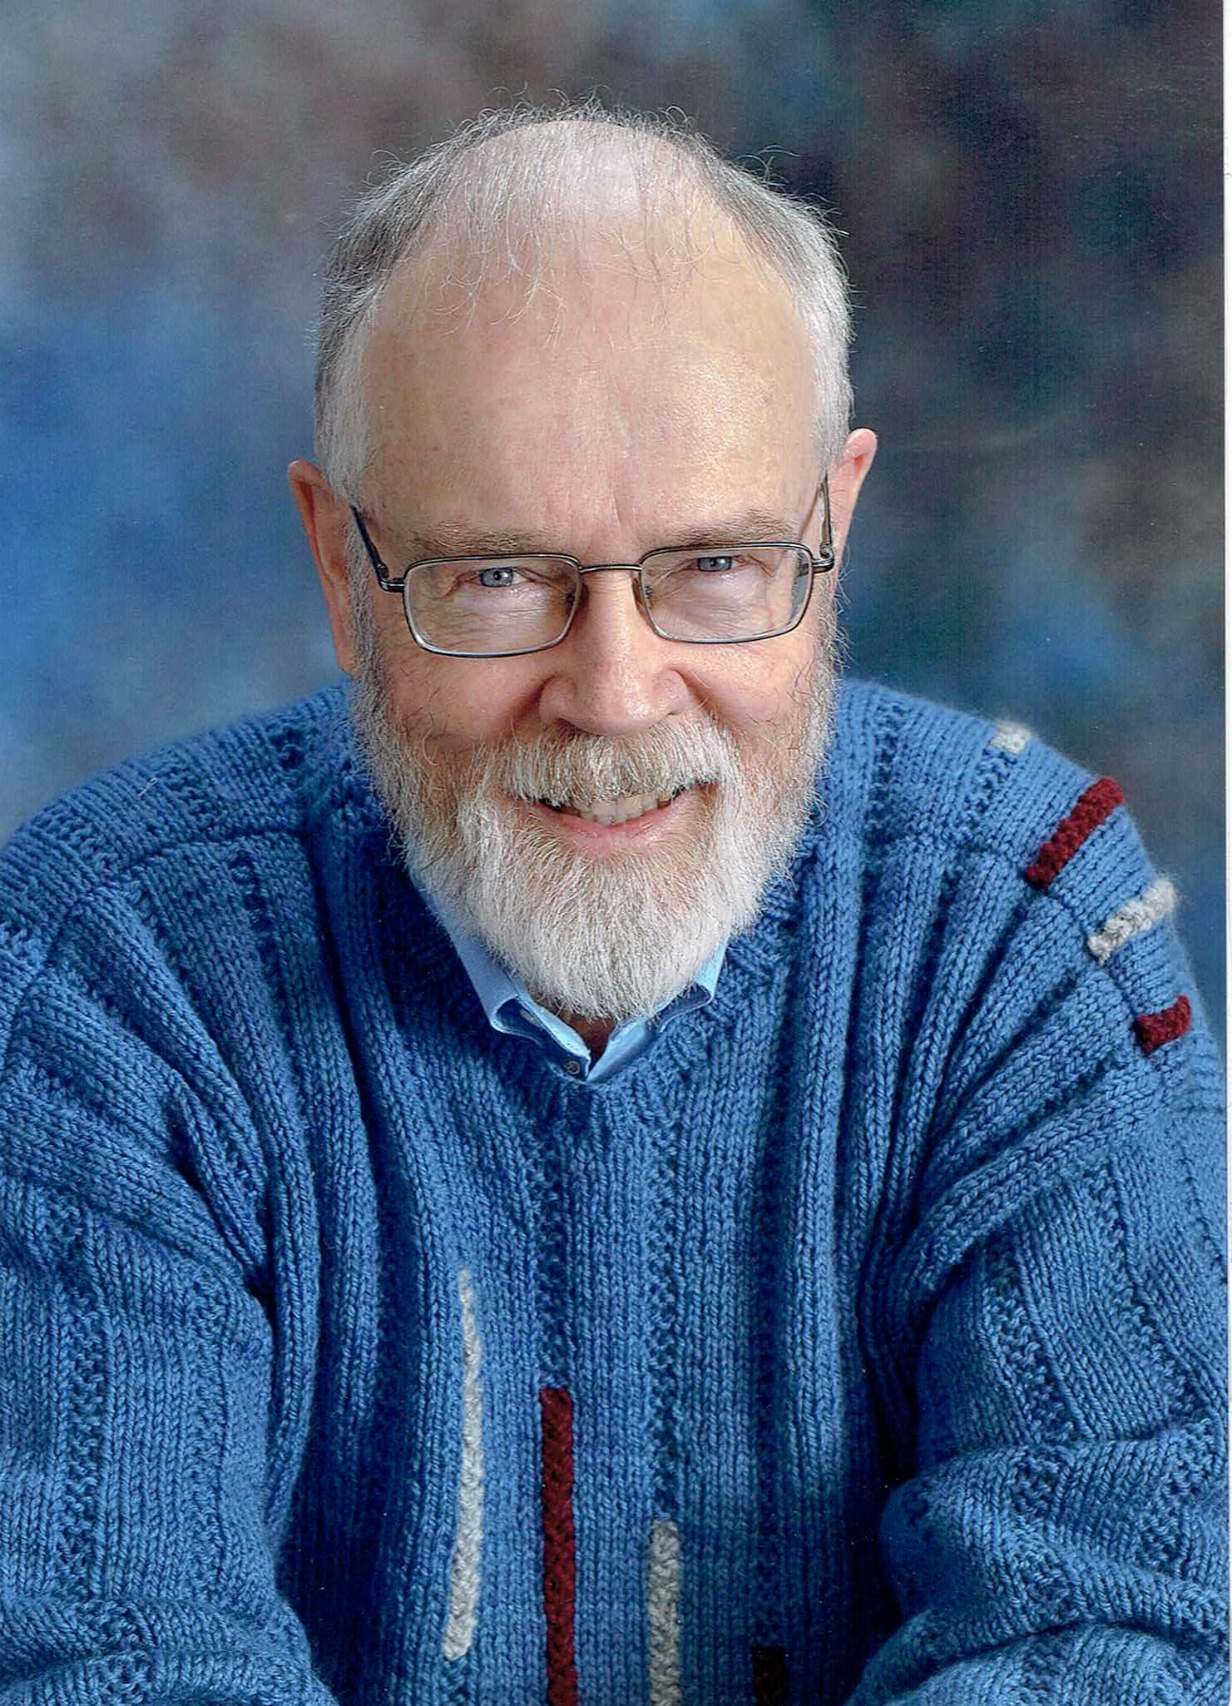
At 2:00 pm on Sunday Oct. 28 former CCHS board member, Dr. Tim Thoresen, will present a program based upon his new book River, Reaper, Rail. His presentation will include a number of stories about Champaign County not included in the book such as his account of the origination of the statue in Monument Square. Attendees can purchase signed copies at a reduced price.

ELECTION NOVEMBER 6 Tell 5 people!

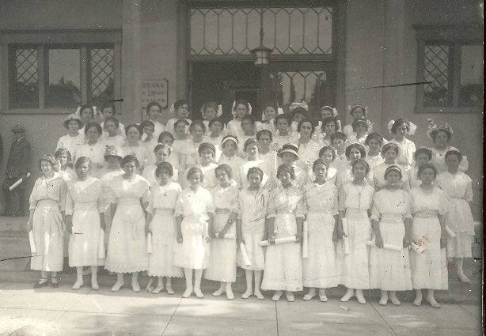
Notable Women of Champaign County
Girls who just took the Boxwell-Patterson Examination early 1900’s
At 6:30 pm on Tuesday Nov. 13 CCHS will host a meeting of Soroptimist International of Urbana, Ohio, and present a program by Gloria Malone, Champaign County Reference Librarian, about local women from all walks of life who helped make Champaign County what it is today. From the first woman prosecuting attorney in Ohio to a woman who was repeatedly arrested for selling beer on Sunday, the stories abound. The museum and program are open to the public and prospective members are particularly invited.

Founded in 1921, Soroptimist International is a world-wide volunteer
service organization for business and professional women who work to
improve the lives of women and girls, in local communities and
throughout the world.

The Glacial Kame in Champaign County

At 2:00 pm on Sunday Nov. 18 well-known archeologist Bob Converse will present a program on ancient Native American settlements near Champaign County.

The Glacial Kame Culture was a culture of Archaic people in North America that occupied southern Ontario, Michigan, Ohio and Indiana from around 8000 BC to 1000 BC. The name of this culture derives from its members' practice of burying their dead atop glacier-deposited gravel hills. Archaeologists specializing in Ohio became familiar with Glacial Kame sooner than with the state's other cultures as this culture's heartland is in Champaign, Hardin, and Logan counties.

The Annual Christmas Buffet Dinner will be served on Sunday December 9 at 5:00 pm at the museum.

Thanks to the generosity of our sponsor, Perpetual Federal Savings Bank, there is no charge for the meal (In Good Taste Catering), but we do need R.S.V.P.’s. Members planning to attend are asked to leave word at the office or simply include the response form with your dues envelope tucked into this newsletter.

Date to remember: CCHS Annual Meeting Jan. 20, 2019

NEW MEMBERS

Gary, Michelle, and John Comer Mechanicsburg John P. Gerros Syracuse, NY
Jesse and Judi Henson Urbana Gregg Jones Wildwood, MO
Ned Kirby Indianapolis, IN Scott Kirby Boulder, CO
Brad and Suzanne McCoy Urbana Linda Stallsmith Urbana
Sarah Stallsmith Urbana Vern Tobias Urbana
Greg and Marcia Ward Urbana Dan and Judy Whitehead St. Paris

Invite your friends! www.champaigncountyhistoricalmuseum.org

ANNUAL DUES

For the convenience of our members an envelope is enclosed for your use in submitting your annual dues. If you joined CCHS after October 1 of this year, you are already paid through 2019. Your renewal date is noted on the front of your newsletter address label. We thank each and every one of you for your continued support.

TO USE THE KROGER COMMUNITY REWARDS PROGRAM TO BENEFIT THE CHAMPAIGN COUNTY HISTORICAL SOCIETY:

- Register online at krogercommunityrewards.com and have your Kroger Plus card handy.
- Click on Sign In/Register (probably as a new “online” customer).
- Click on My Account and input your Kroger Plus card number.
- Enter our NPO number (WV073) or the name of our organization (Champaign County Historical Society).
- Do you use your phone number at the register? Call 877-576-7587 to get your Kroger Plus card number if you no longer have your card or have forgotten it.
- Fuel points will not be affected.

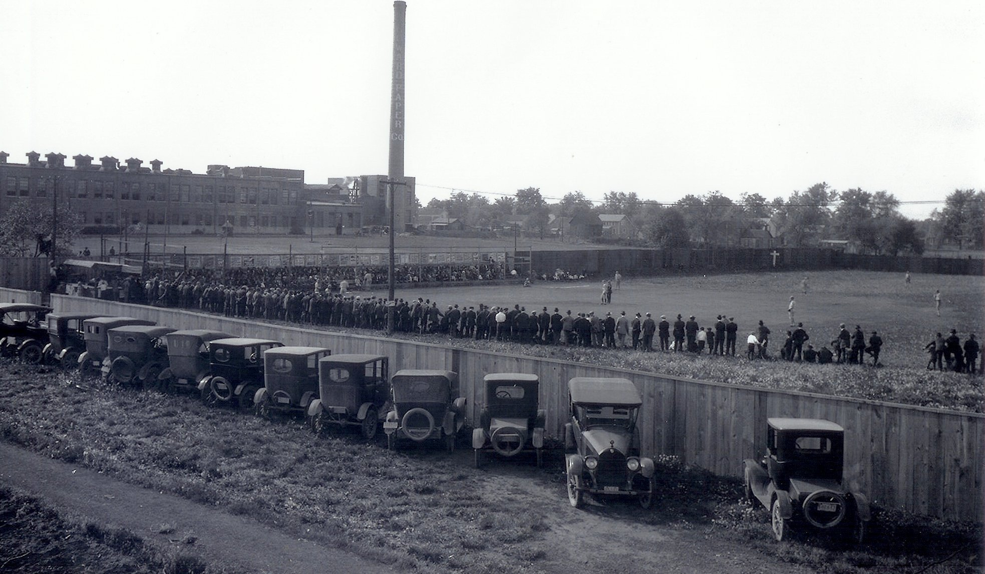
Urbana baseball field near Howard Paper Mill. What can you tell us about it?

