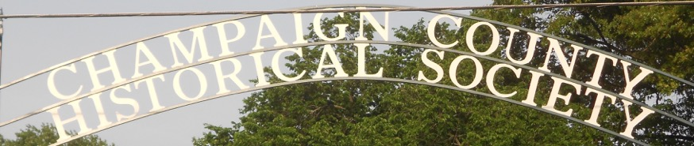
Est. 1934 January/February 2018
809 E Lawn Ave Urbana, Ohio 43078 www.champaigncountyhistoricalmuseum.org
Victory Through Education !
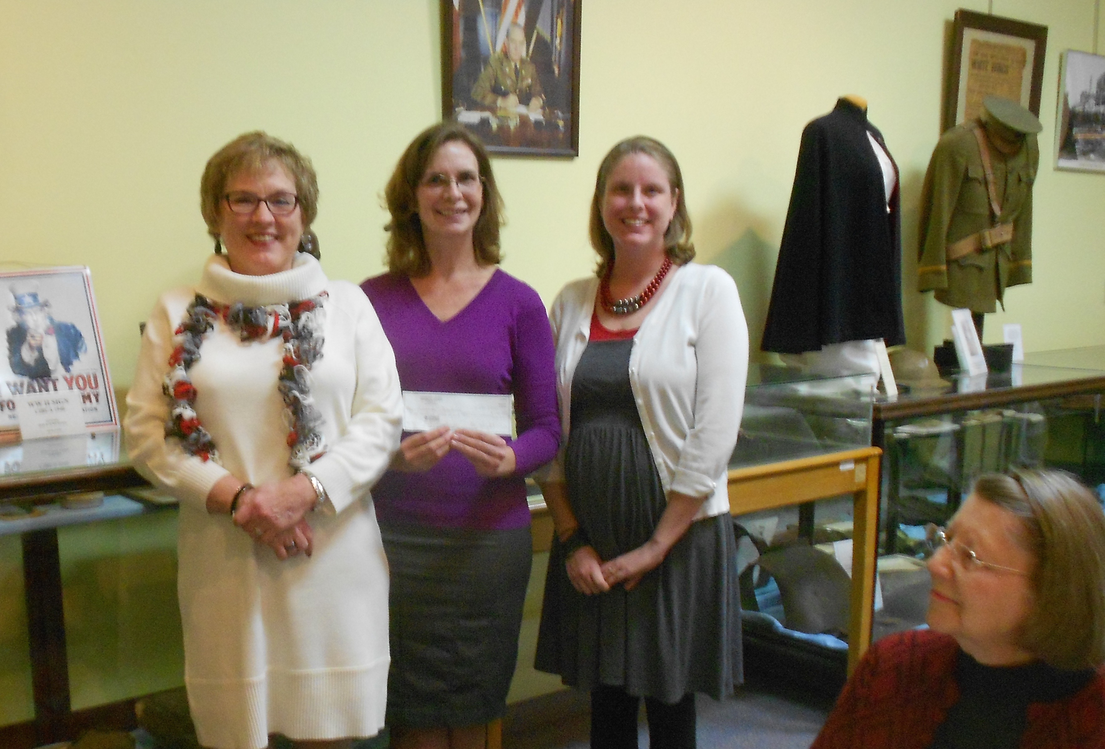
During the Christmas Dinner on December 4 CCHS Education Outreach Chair Terri Marratta presented a check for $100 to Urbana Junior High teachers Amanda Goodwin and Sadie Steffan. The grant will be used to further eighth-grade social studies. This is just the beginning of a new undertaking by our society to augment the teaching of local history throughout Champaign County. CCHS will continue to grant $100 per year to any and all county school districts requesting such assistance.

President’s Update

2018 is a new year, and, despite November’s setback, your historical society is taking a fresh approach
as evidenced by this newsletter’s redesign. In addition to regular meetings the board has met informally in “round-table” style. As we’ll not be hiring staff in the foreseeable future, the discussions have centered around how best to accomplish our mission of preserving and presenting the artifacts and history of Champaign County by utilizing volunteers.

Trustees’ suggestions range from the traditional to the “out-of-the-box.” All agree that educational outreach is an important program worthy of expansion, and, as noted on page one, this is underway. Treasurer Ken Wright has submitted a written proposal for, among other things, the implementation of an extensive volunteer program. His title, “The Path Forward,” well represents our visioning process.

A new start may include opening the museum to the public on Sunday afternoons. This would not happen until Spring in order to give us time to enlist from our membership a corps of volunteers who are willing to serve as trained docents. Members who would like to become docents or to volunteer in other capacities are encouraged to contact us by phone (653-6721) or e-mail (champhistmus@ctcn.net).

- Dan Walter

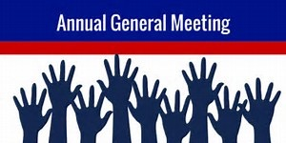
Coming Events

This year’s Annual Meeting will be held at the museum on Sunday January 21, 2018, at 2:00 pm. As always there will be a business meeting during which those nominated as officers and trustees will be introduced and voted upon as will revisions of the Constitution and By-Laws. During the course of 2017 the board has revised and updated both the Constitution and the By-Laws of our organization to bring them into concordance with new Ohio Secretary of State guidelines for not-for-profit volunteer organizations. All changes were administrative in nature. There were no changes made to the number of officers or trustees authorized, nor were there any changes in the manner in which the organization is governed and managed. Those attending will receive printed copies, but in the meantime they may be downloaded from our website.

Once the business meeting has been completed, Urbana Mayor Bill Bean will present a program. Bill is a long-time student of Civil War history and has done considerable research in this area.

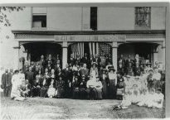
African-Americans from Champaign County who served in the Civil War

On Sunday February 25 at 2:00 pm Margaret Piatt and Amanda Goodwin will present a program entitled Generational Shifts: Attitudes about Slavery and the Anti-Slavery Movement concerning the institution of slavery and the abolition movement in the Nineteenth Century, particularly as related to Piatt family members.

On Sunday March 18 at 2:00 pm Al Bailey will present a program about Dayton Honor Flight whose mission is to take veterans of the WWII, Korean, and Vietnam Wars to see their national memorials in Washington, D.C..

New Members

Heather Angus Urbana David Bishop Urbana
Margaret Denzer Urbana Ruth Harmon Conover
Sheila Zirkle Columbus

