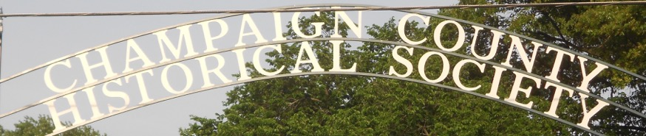
CHAMPAIGN CHRONICLES
Est. 1934 May/June 2018
809 E Lawn Ave Urbana, Ohio 43078 www.champaigncountyhistoricalmuseum.org
History of North Lewisburg Celebrated

On the evening of March 20, former village Mayor and County Commissioner Max Coates presented a program delineating the rich history of N. Lewisburg to a capacity crowd. The event was held in the historic N.. Lewisburg Library, formerly the Evangelical Friends Church. Assisting Max was his wife Janice, former President of our society. Willis Spain (1796-1881) and Nancy Epps Spain (1797-1881), 4G grandparents of Mr. Coates, are credited as the first permanent settlers in the N. Lewisburg area in the Fall of 1805.
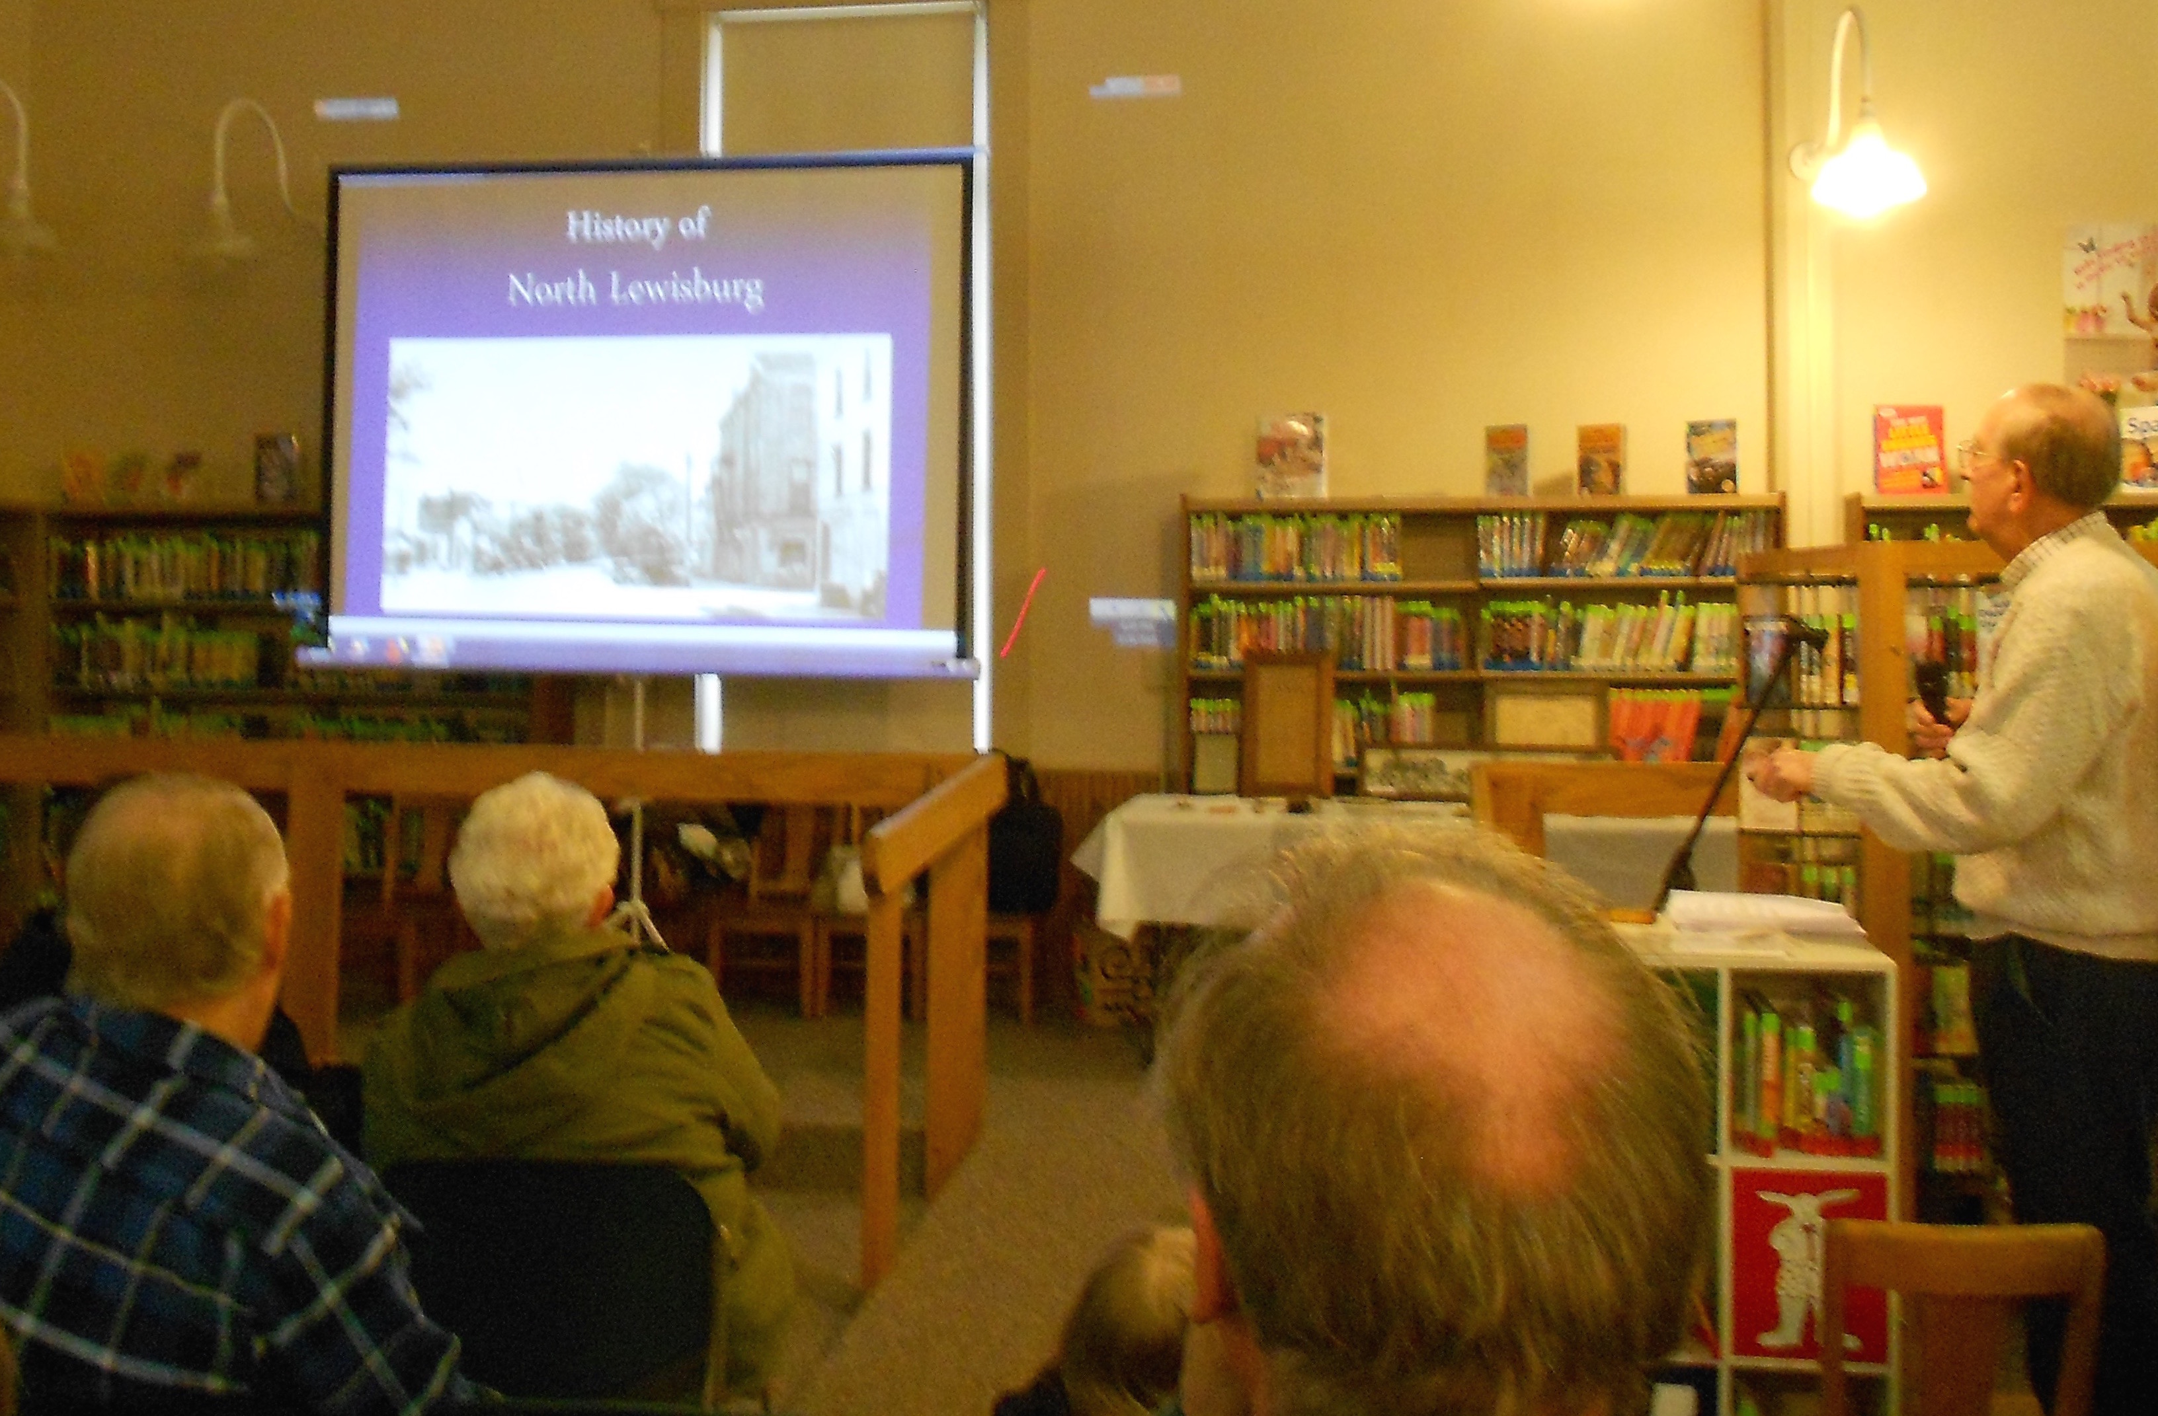
EDUCATIONAL OUTREACH !
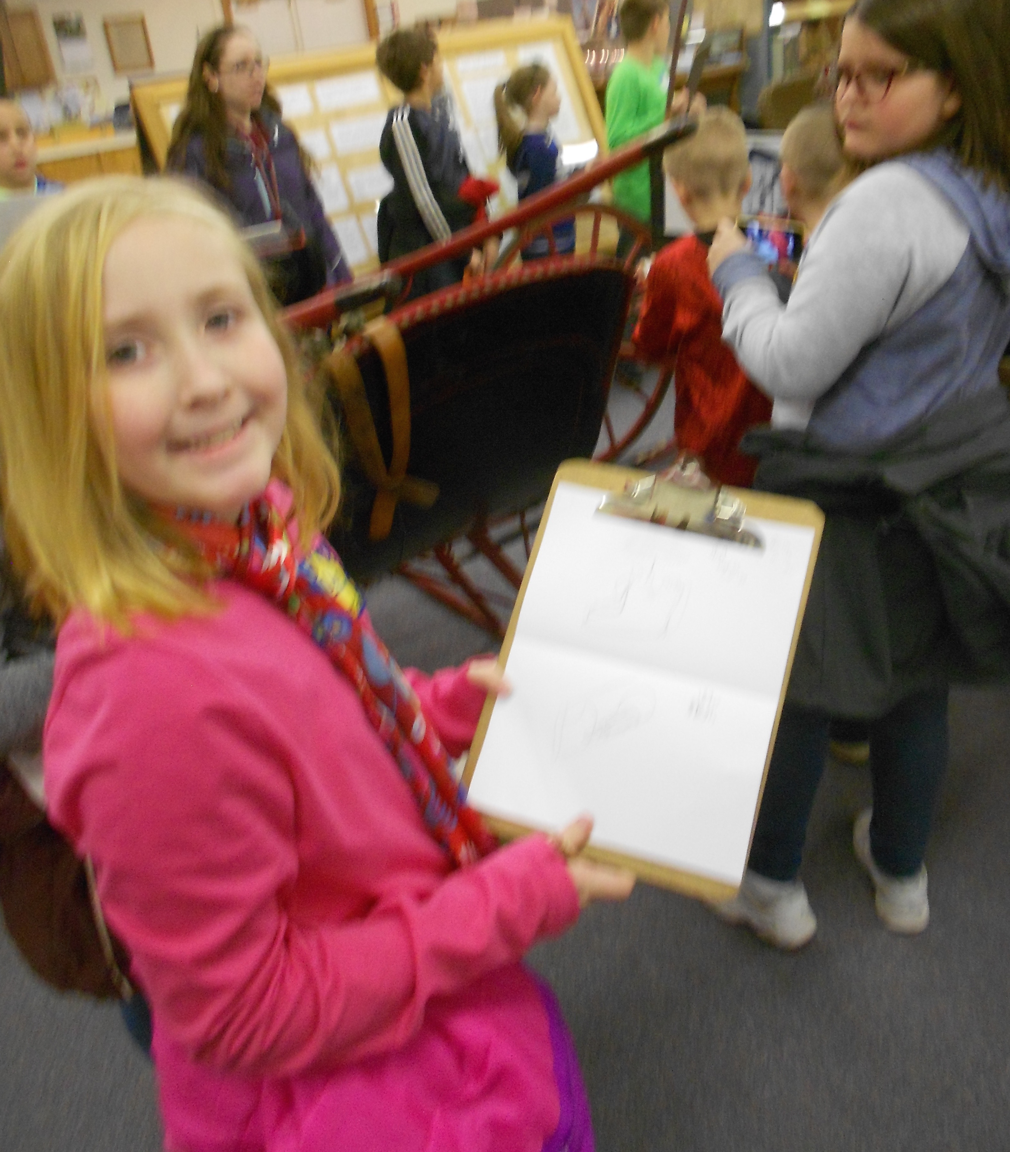
On March 12 third grade students from South Elementary, Urbana, visited our museum and divided in to groups utilizing the teaching method Project Based Learning, or PBL. This year’s project is entitled Champaign County Change Over Time. Pictured above, student Quinzel Hawkins displays her notes in the area of transportation. The project will culminate May 2 with presentations in the school gym. All Champaign County elementary schools have been invited to the museum this Spring.

President’s Update

We have long recognized the need to open our museum to the public more often. We are not yet in a position to hire full-time staff to open five-six days/week but are ever hopeful that the voters of Champaign County will support us in the future. In the meantime volunteers have stepped forward and participated in docent training. As a result we are proud to announce that in addition to Mondays and Tuesdays the museum will soon be open on Sunday afternoons from 1:00 - 5:00 pm. The first Sunday opening will be April 29.

Members who would like to become docents or to volunteer in other capacities, perhaps as greeters, are encouraged to contact us by phone (653-6721) or e-mail (champhistmus@ctcn.net).

Community Wins Challenge. This is an event hosted by Memorial Urbana Medical Center for the purpose of promoting the grand opening of their new facility at 1958 E. US Hwy 36. The idea is to benefit Champaign County non-profit organizations. We are registered and are eligible to win one of $6,000 in prizes. To support us simply stop out at the grand opening anytime from 3-7 pm Thursday April 26 and cast your vote for your Champaign County Historical Society. Tell your friends!
-Dan Walter

COMING EVENTS

On Sunday May 13 at 2:00 pm LOGAN BOGGS will present a program entitled History of the World - With Some Jokes.

Boggs, who is both historian and comedian, recognizing that too often history is presented as a dry string of facts and dates meant to be memorized, melds a history lecture with stand-up comedy designed to entertain a wide audience - students, scholars, and just plain folks - with some jokes. And he manages to explain the entire History of the World in just twenty-five minutes!

Prior to the performance students who reached the state level in the National History Day competition this year will be recognized.

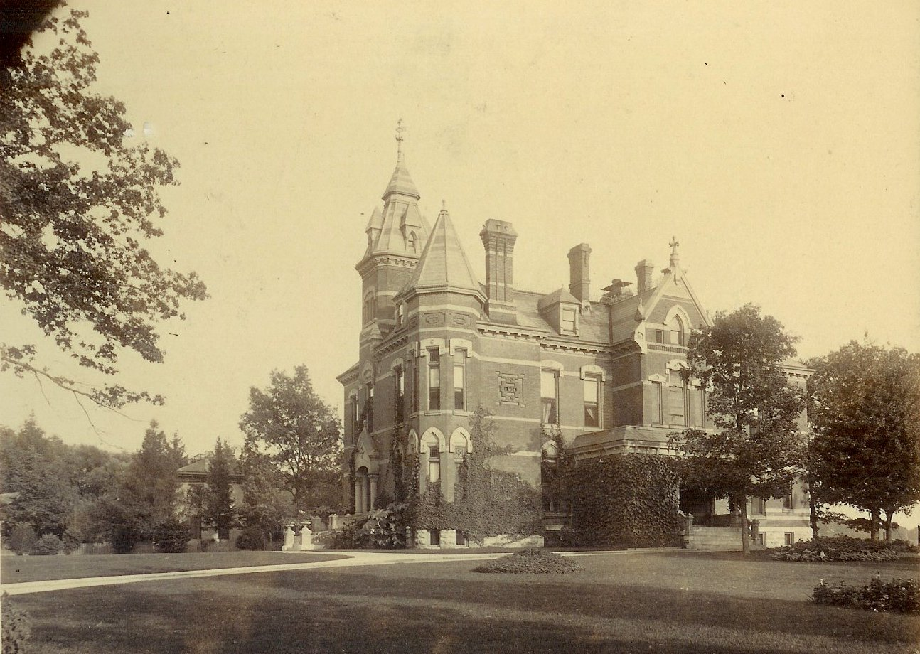
On Sunday June 17 at 2:00 pm NED KIRBY will present a program of family history with emphasis on the historic properties owned by the family. Featured will be 591 Scioto Street pictured here, both interior and exterior.

Also featured will be 601 Scioto to include the summer house and carriage barn, the Kirby Farm and Kirby Ranch (late 1800’s), Kirby Kabin, and the 1950 National Plowing Matches. Several original oil paintings will round out the display. Copies of Kirby’s books will be available for purchase with all proceeds benefiting the Champaign County Historical Society.
On Sunday July 8 at 2:00 pm longtime DJ and historian DICK HATFIELD will present his recollections of The Coconut Lounge. You’ll not want to miss this trip down memory lane when the likes of the Beach Boys, Four Seasons, and others appeared at a nightclub in rural Champaign County. More in our next issue!

New Members

Sandy and Ernest Avery Scott Jones
Rev. Carol Tong Barry Ward
Janet Wright Gary Wyant
Janet and Kim Yost

Invite your friends! www.champaigncountyhistoricalmuseum.org

