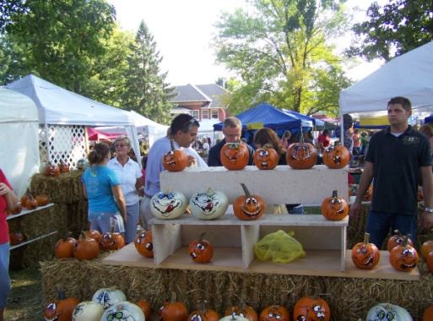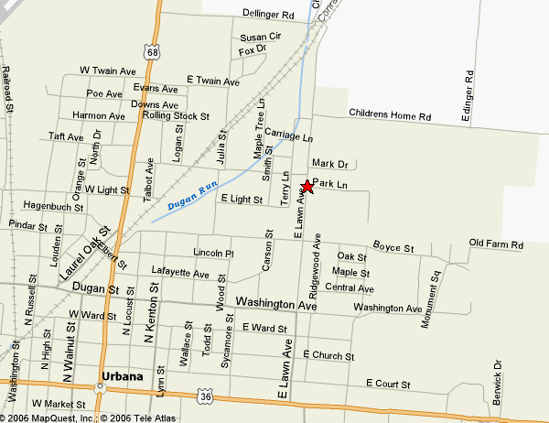**Champaign County Historical Society**

**50th** **Annual**

**OKTOBERFEST**

**VENDOR** Application

Sunday, October 2, 2022

10:00 A.M.-4:00 P.M.

809 East Lawn Ave.

Urbana, OH 43078

**FEE:**  Outdoor space only (10 ft. by 10 ft.) cost is $35.00. No subletting of booth space will be allowed. **Limited** outdoor space with electricity (10 ft. by 10 ft.) cost $50.00. Entry fees are not refundable after August 31, 2022. There will be refunds only upon cancellation of **OKTOBERFEST**. There is no rain date. Two individuals per exhibit will receive a pass. **DUE TO LIMITED SPACE, ENTRIES WILL BE PROCESSED ON A FIRST COME FIRST SERVE BASIS.**

**ELIGIBILITY:** To apply for this year’s festival, all new exhibitors and exhibitors who have new crafts will be juried by submitting a minimum of three photos of your new craft. All exhibits will be limited to high quality, handcrafted, arts and crafts. ***Imported and mass-produced or factory-made items will be rejected****.* Also send a **SELF-ADDRESSED, STAMPED, BUSINESS SIZE ENVELOPE** **WITH YOUR APPLICATION AND YOUR BOOTH FEE** no later than September 24, 2022. A contract with your tickets will be sent as soon as possible. A committee will determine which items will be accepted. If your exhibit is rejected your check will be returned by the Oktoberfest Committee. Artist and crafts people, in addition to exhibiting and/or retailing their work, are asked to demonstrate their craft, if at all possible.

**FACILITIES:** Display areas are provided on the spacious lawn at the museum. Exhibitors must provide their own display equipment, tents, tables, and chairs. Spaces supplying electricity are **limited** and must be approved by the committee. Exhibits can be set up prior to Sunday morning at your own risk. All exhibits must be in place and set-up by 10:00 A.M. Any vehicle remaining on the show grounds after 10:00 A.M. without permission, will be towed. Dismantling exhibits, or bringing vehicles onto the grounds, before 4:00 P.M. without Society management approval will be considered cause for rejection at future Oktoberfests.

Complete the attached form, send a self-addressed, stamped, business sized envelope with application and mail to:

Champaign County Historical Society

809 East Lawn Ave.

Urbana, OH 43078

champaigncohistory@gmail.com www.champaigncountyhistoricalmuseum.org 937-653-6721

**cut here_______________________________________________________________________________________________**

Return this portion only and please fill-out completely CCHS use only

Appl.#___________

**APPLICATION FOR OKTOBERFEST**, (October 2, 2022) Date____________

Ck.#____________

Ck.Date___________ NAME : (as you want it to appear in promotional material)_______________________________________ Amt._____________

NAME OF PERSON APPLYING__________________________________________________________________

STREET__________________________CITY______________________________STATE/ZIP________________

PHONE___________________________EMAIL_____________________________________________________

List your name and one other person who will be admitted free with your exhibit:

1.)_________________________________________2.)_______________________________________________

Have you exhibited here previously?______________

Please write a brief description of your art or craft for your exhibit, this will also be sent to your home town newspaper.________

______________________________________________________________________________________________________

COMMENTS:___________________________________________________________________________________________